|  |  |  |  |  |  |  |  |  |  |  |  |  |  |  |  |  |  |
| --- | --- | --- | --- | --- | --- | --- | --- | --- | --- | --- | --- | --- | --- | --- | --- | --- | --- |
| No | Banyak Pertemuan | 1 | 2 | 3 | 4 | 5 | 6 | 7 | 8 | 9 | 10 | 11 | 12 | 13 | 14 | 15 |  |
| 1 | Analisa Soal |  |  |  |  |  |  |  |  |  |  |  |  |  |  |  |  |
| 2 | Persiapan Perangkat keras |  |  |  |  |  |  |  |  |  |  |  |  |  |  |  |  |
| 3 | Persiapan perangkat lunak |  |  |  |  |  |  |  |  |  |  |  |  |  |  |  |  |
| 4 | Perancangan Algoritma |  |  |  |  |  |  |  |  |  |  |  |  |  |  |  |  |
| 5 | implementasi data base untuk mysqli |  |  |  |  |  |  |  |  |  |  |  |  |  |  |  |  |
| 6 | Desain user interface |  |  |  |  |  |  |  |  |  |  |  |  |  |  |  |  |
| 7 | Koding struktur html |  |  |  |  |  |  |  |  |  |  |  |  |  |  |  |  |
| 8 | Koding style css |  |  |  |  |  |  |  |  |  |  |  |  |  |  |  |  |
| 9 | Koding php |  |  |  |  |  |  |  |  |  |  |  |  |  |  |  |  |
| 10 | Uji coba aplikasi |  |  |  |  |  |  |  |  |  |  |  |  |  |  |  |  |

**Time Schedule**

ERD

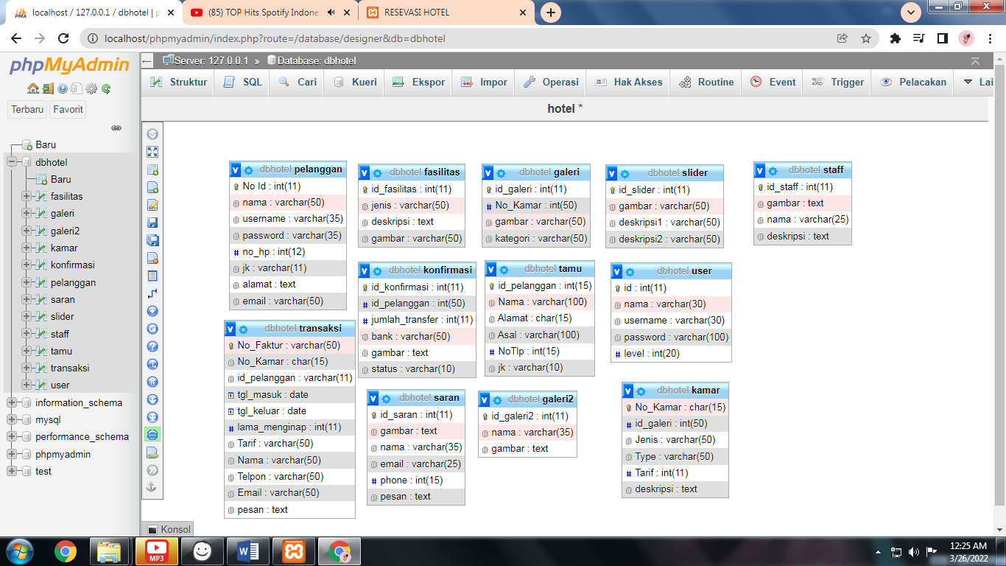

Data dummy

Tb_user

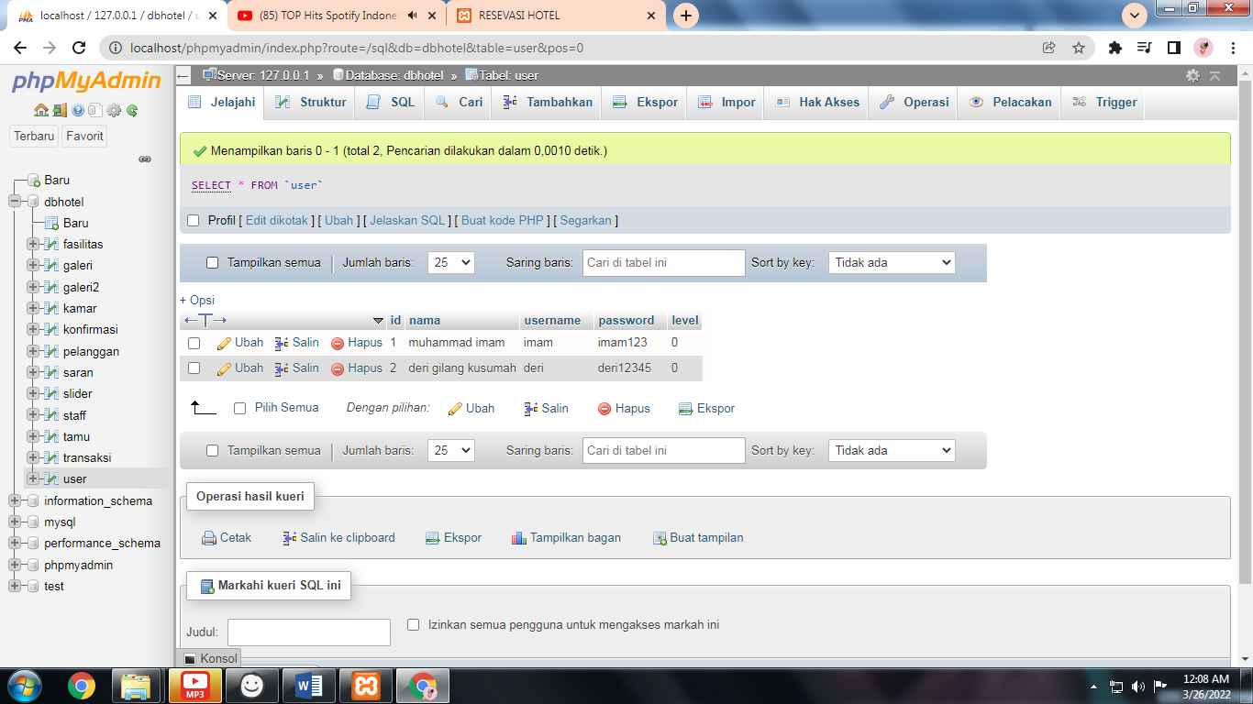

Tb_fasilitas

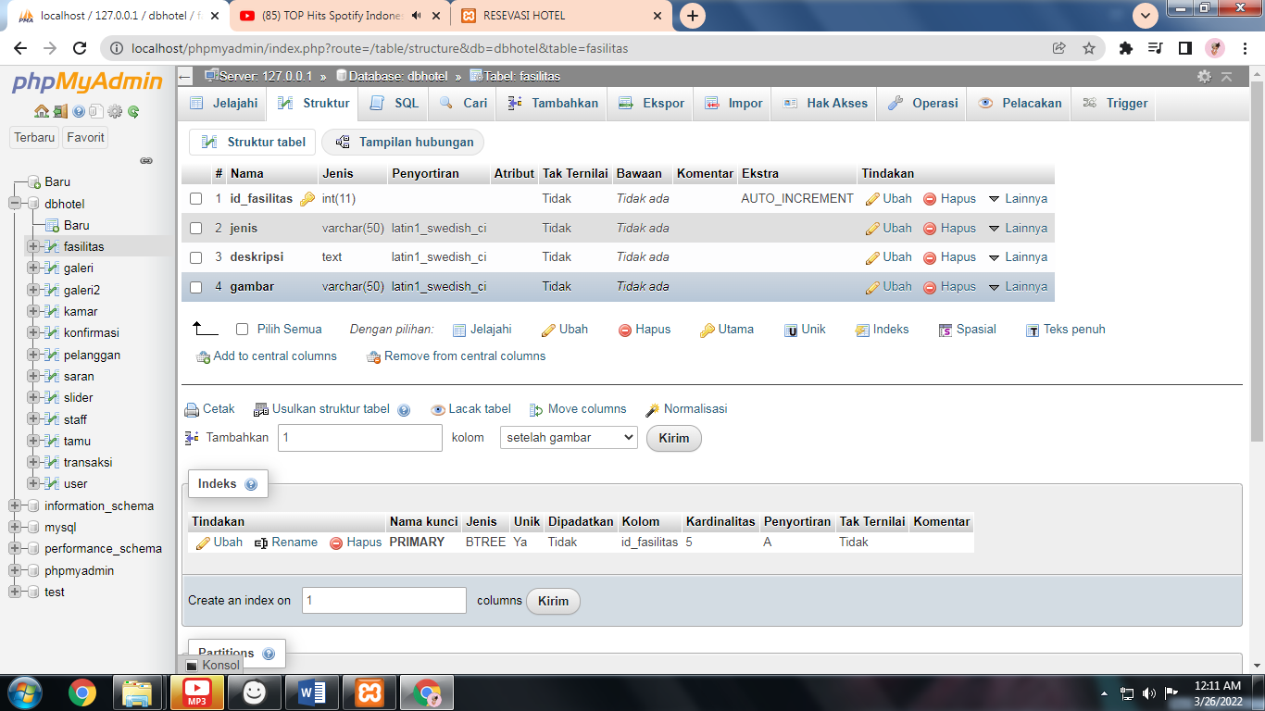

Tb_kamar

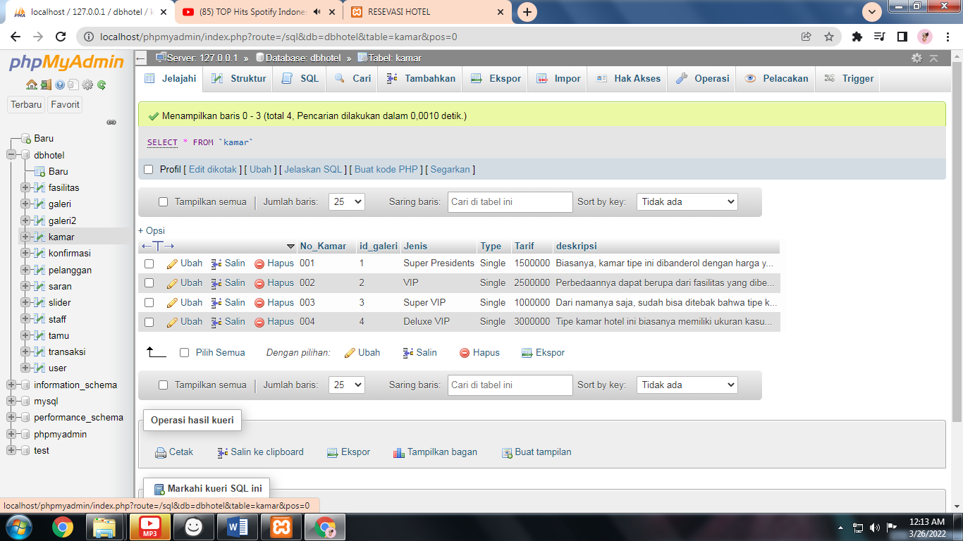

Tb_slider

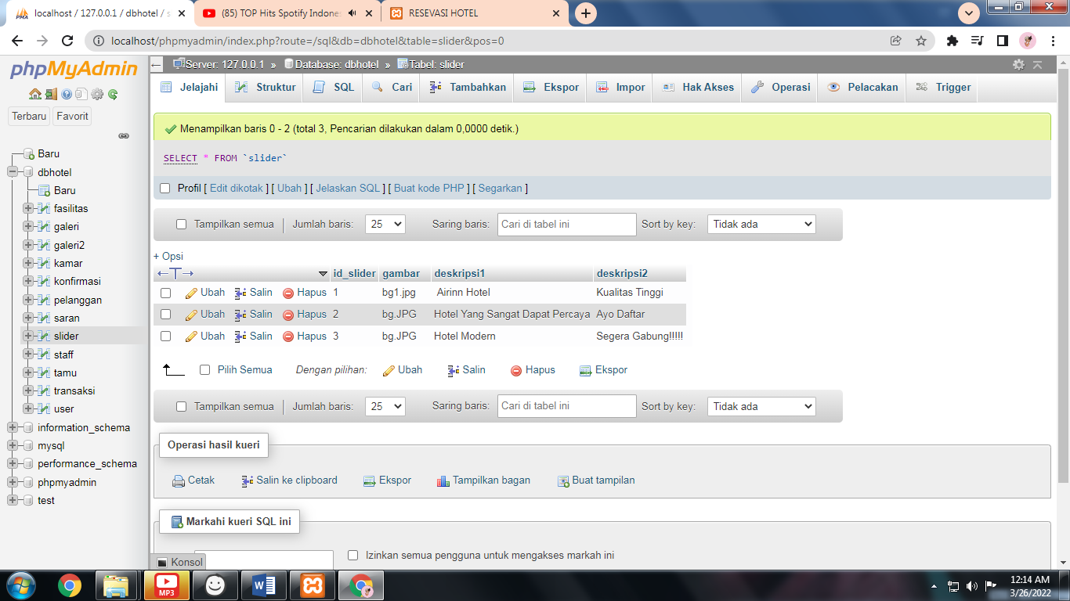

Tb_galeri2

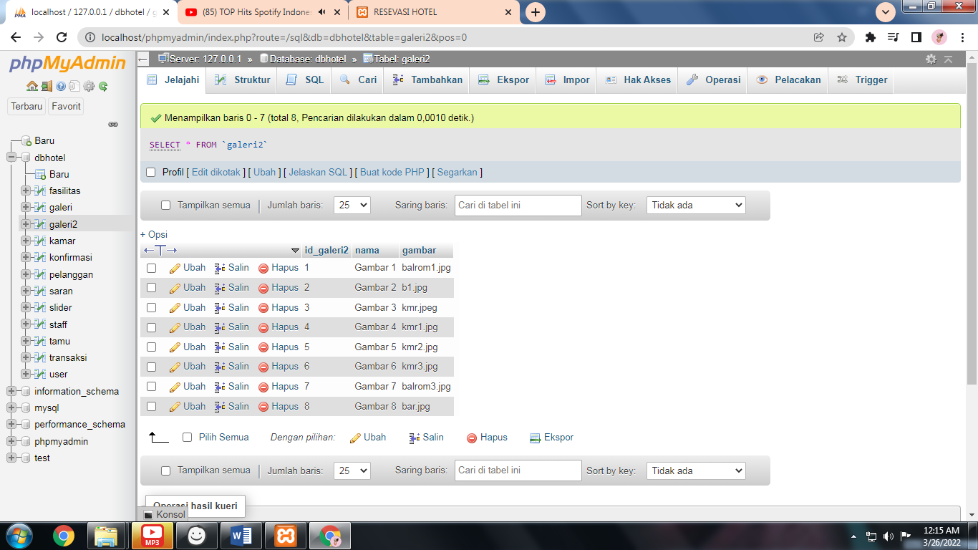

Tb_fasilitas

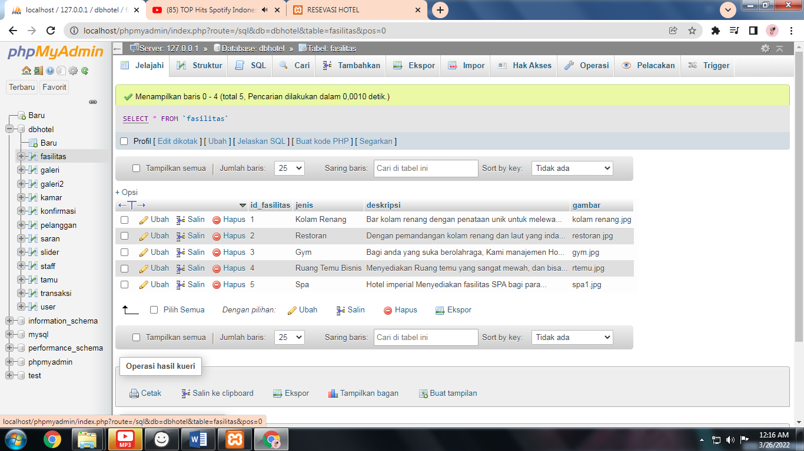

Tb_galeri

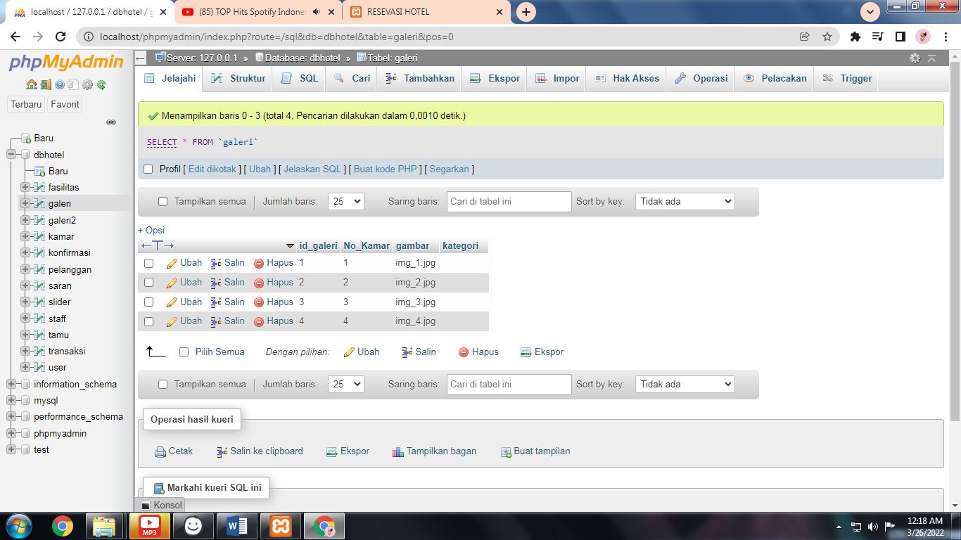

Tb_konfirmasi

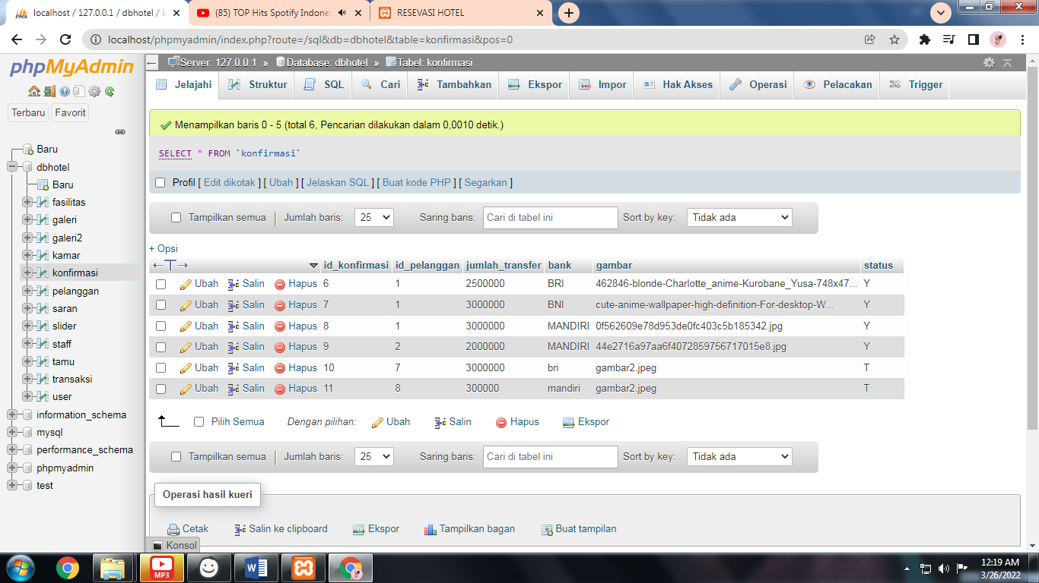

Tb_pelanggan

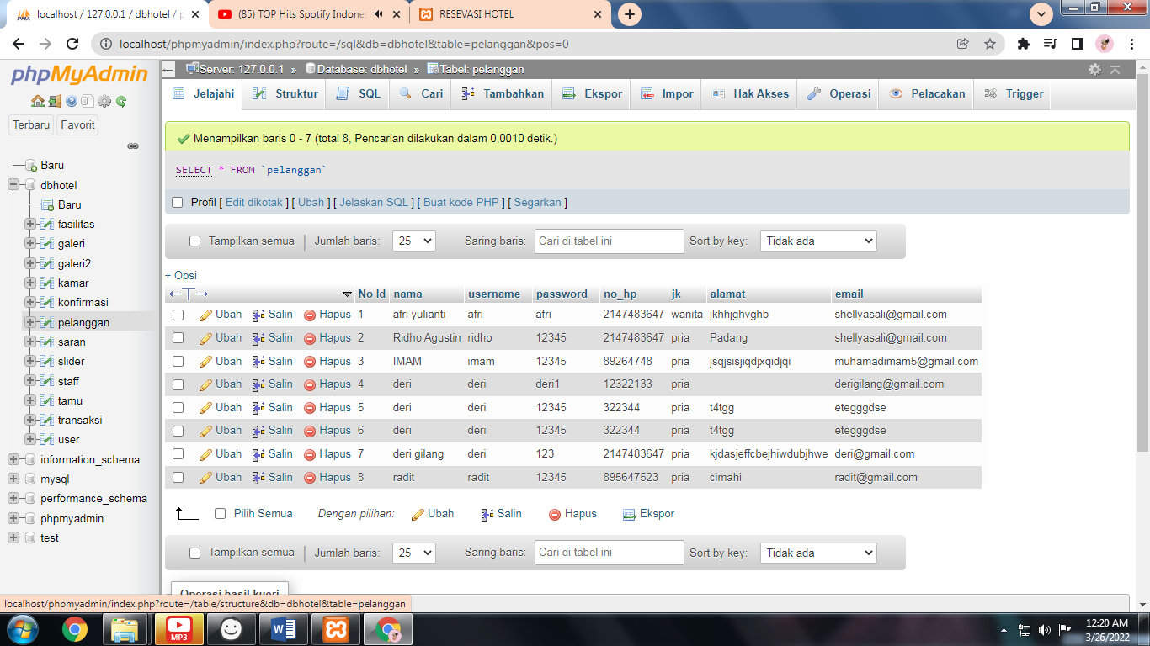

Tb_saran

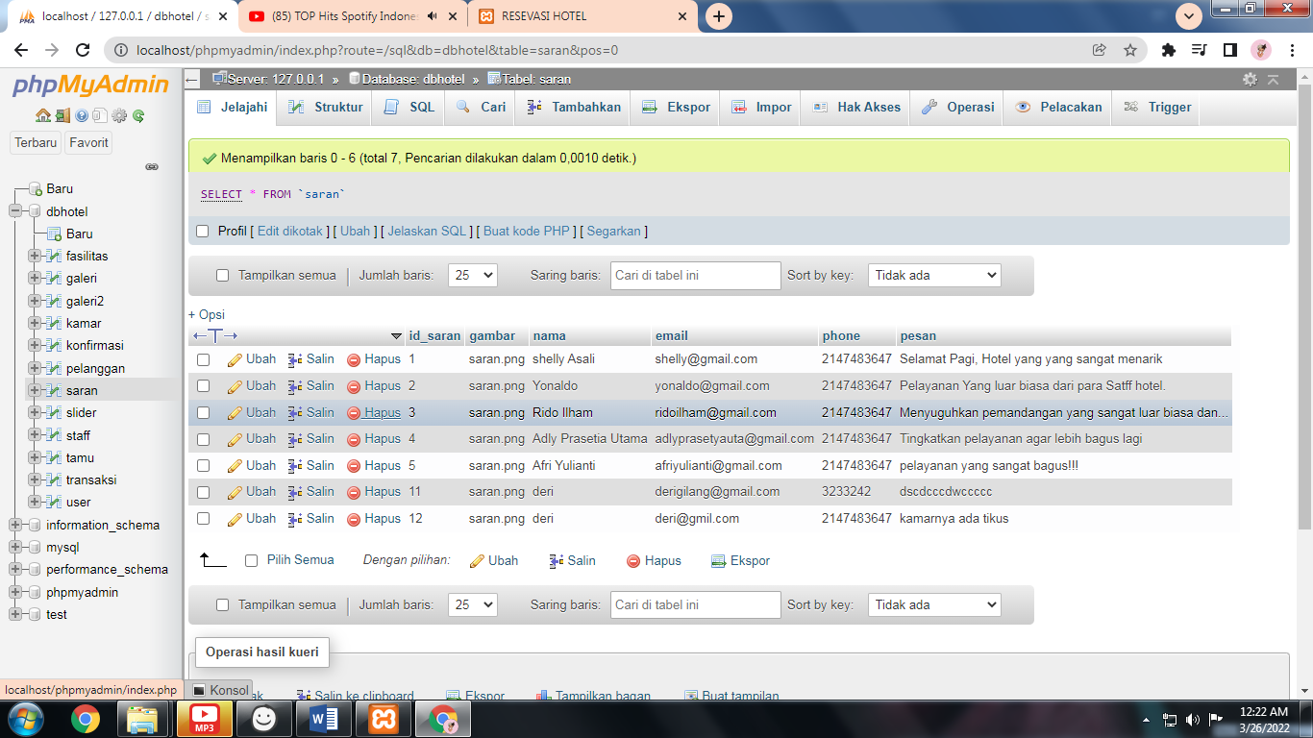

Tb_tamu

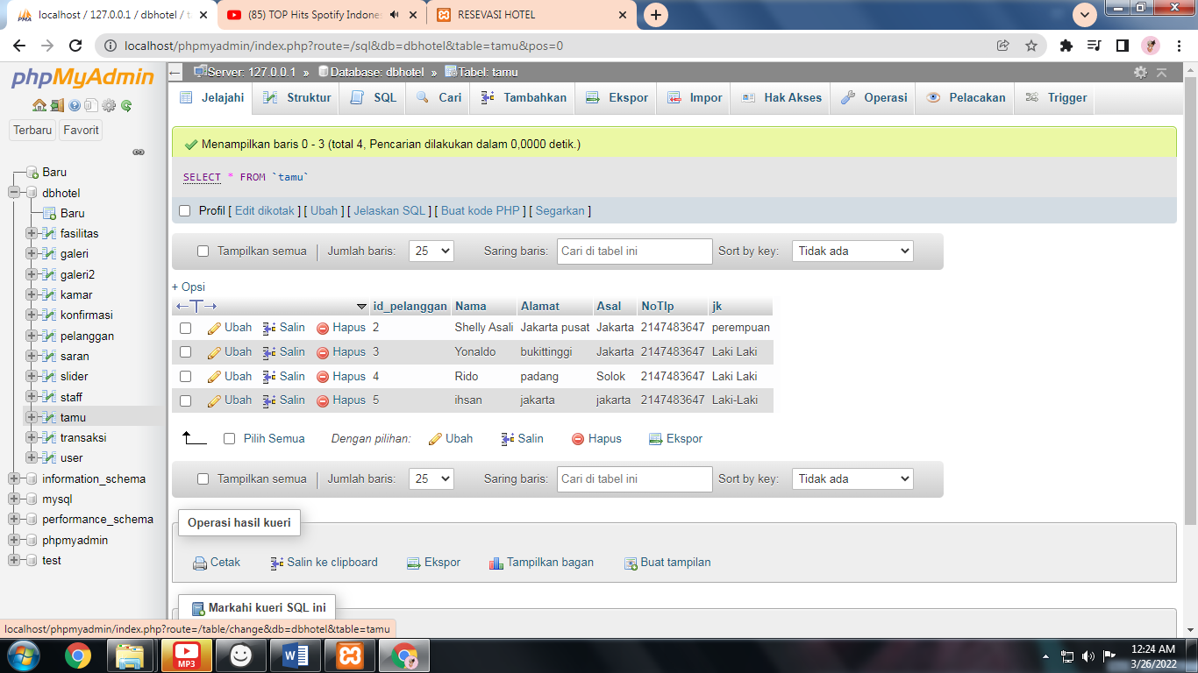

**Algoritma**

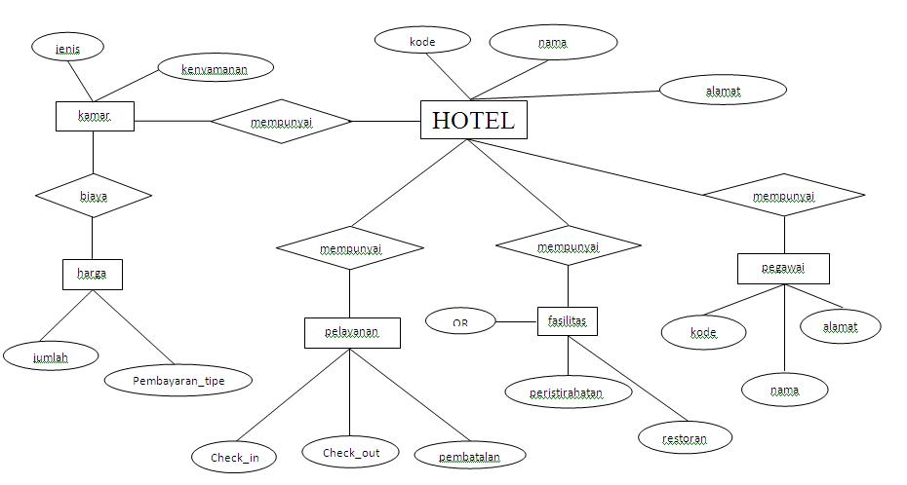

**Mockup**

Halaman Utama

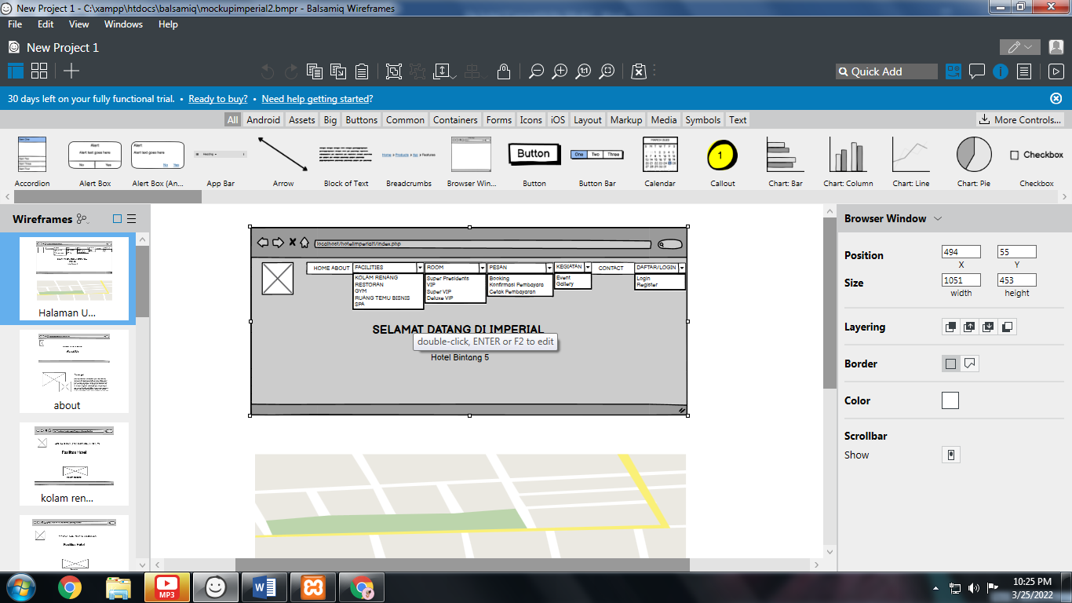

About

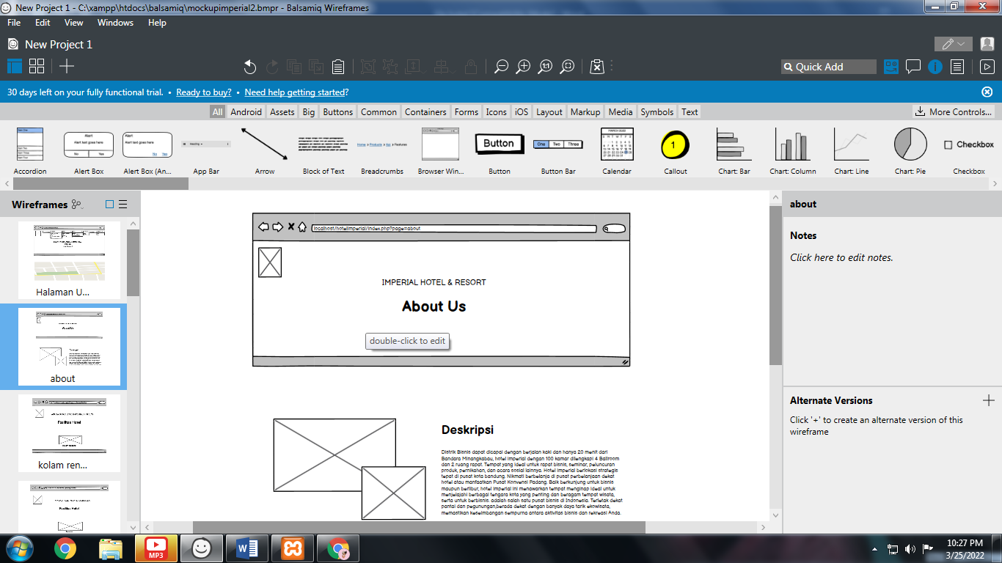

Kolam renang

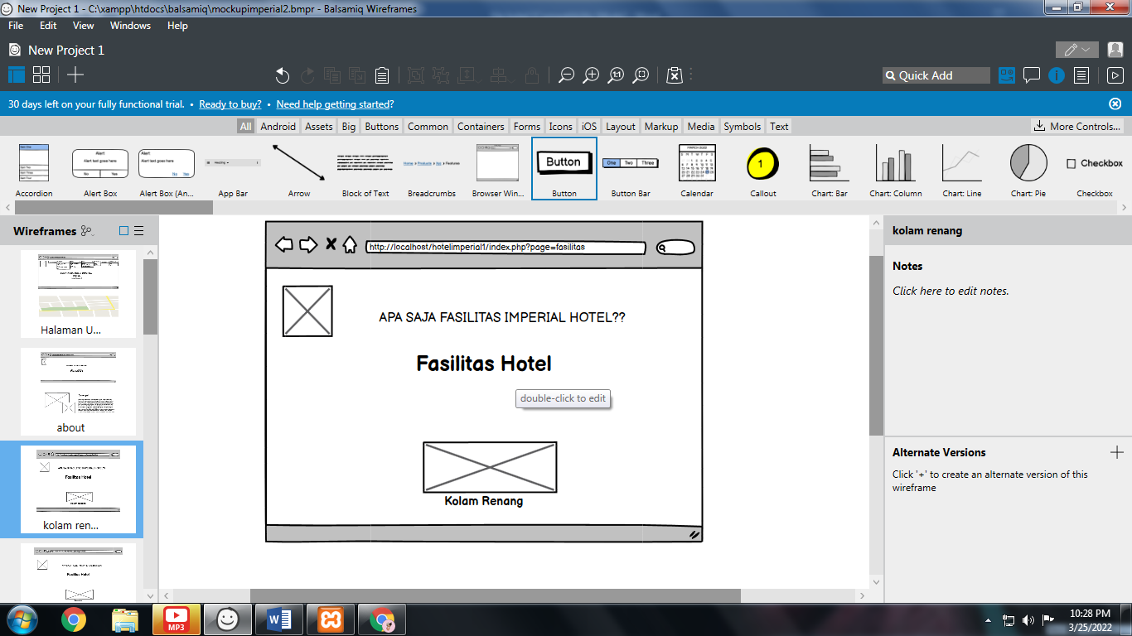

Restoran

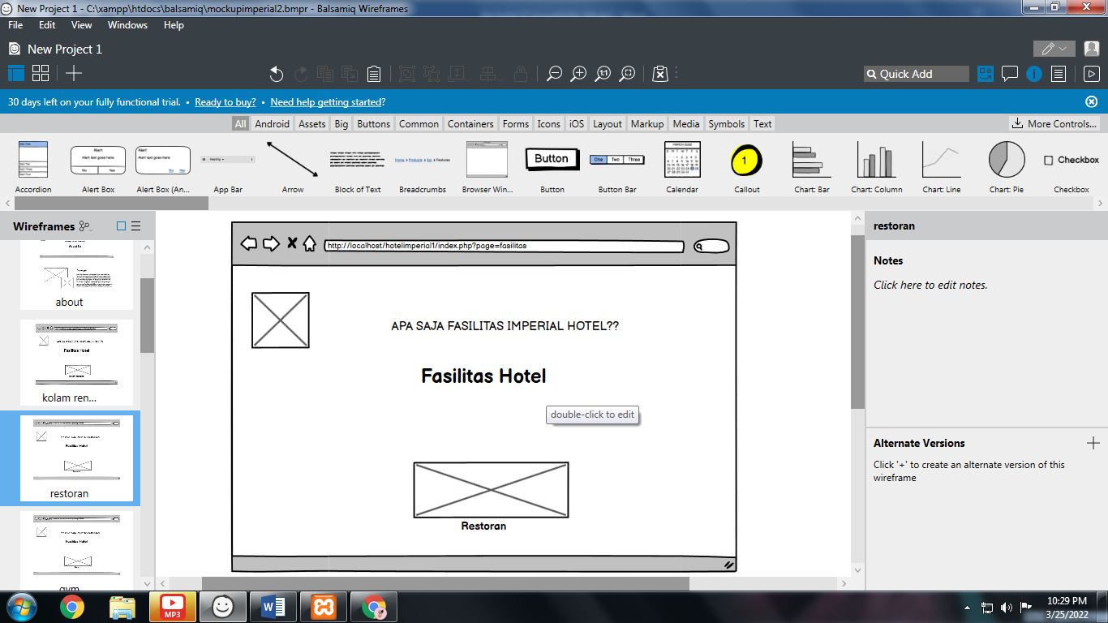

Gym

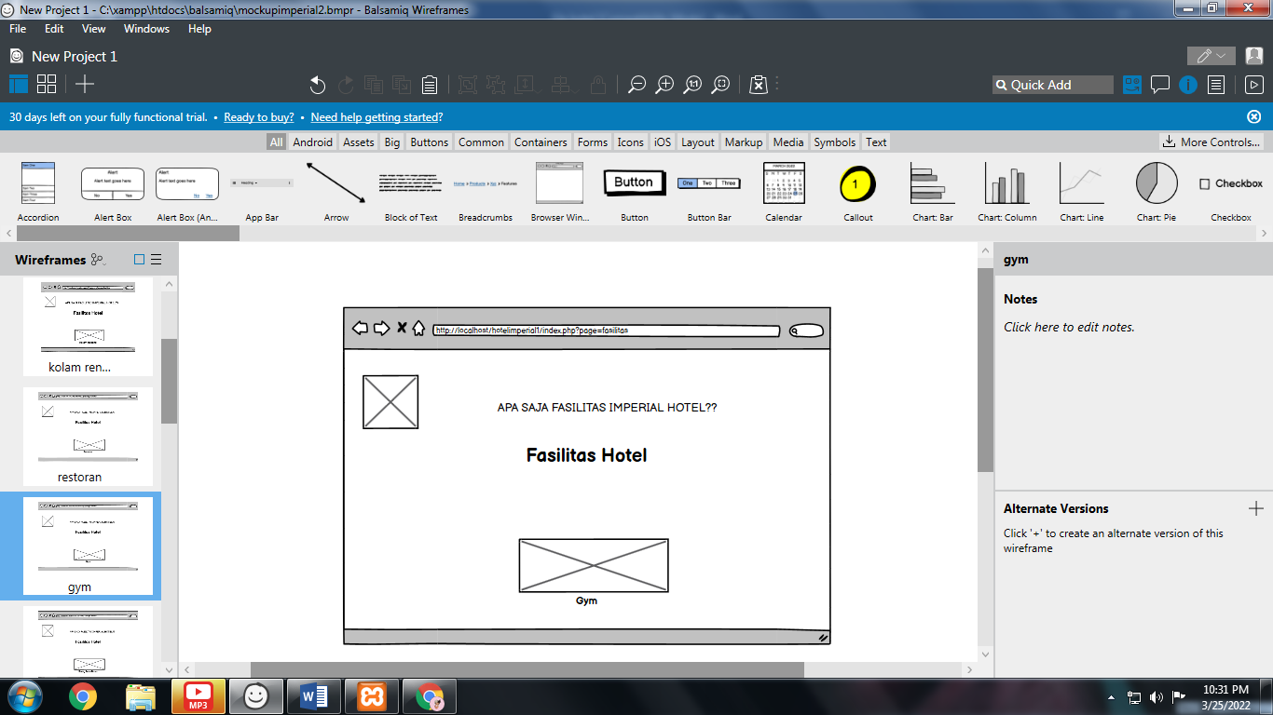

Ruang temu bisnis

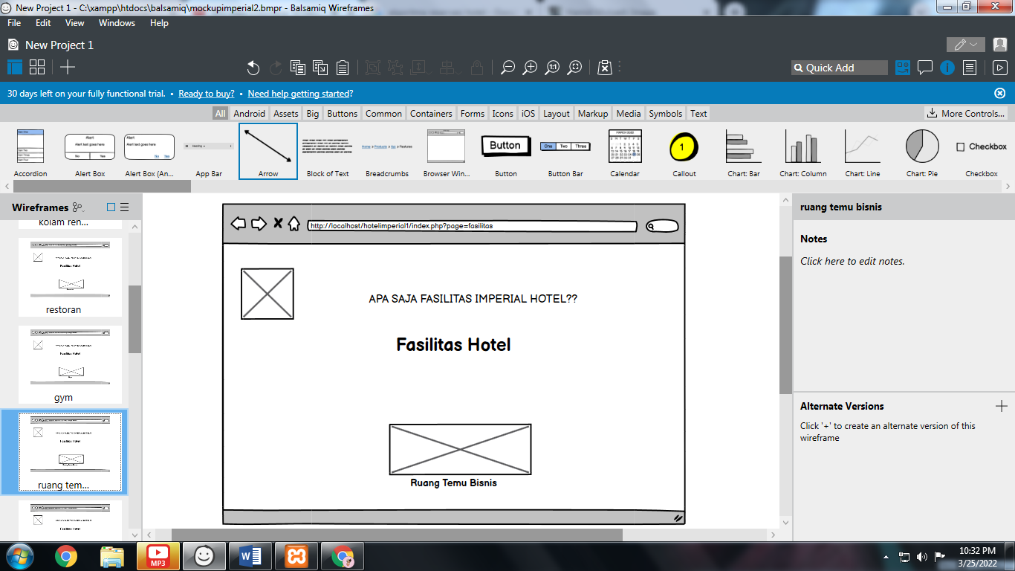

Spa

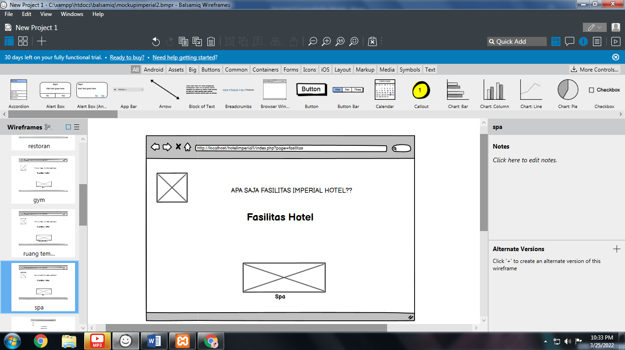

Room

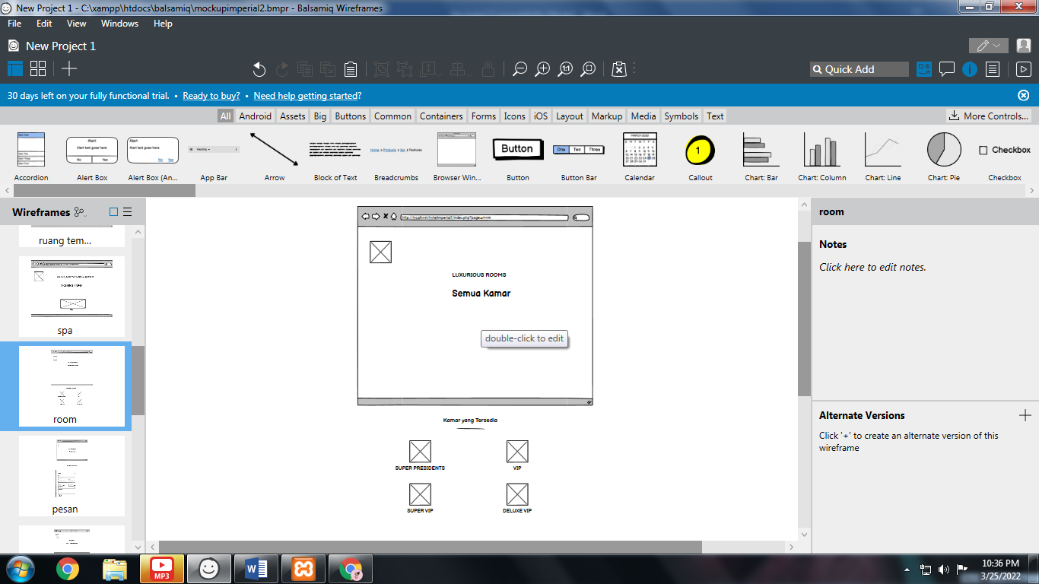

Pemesanan

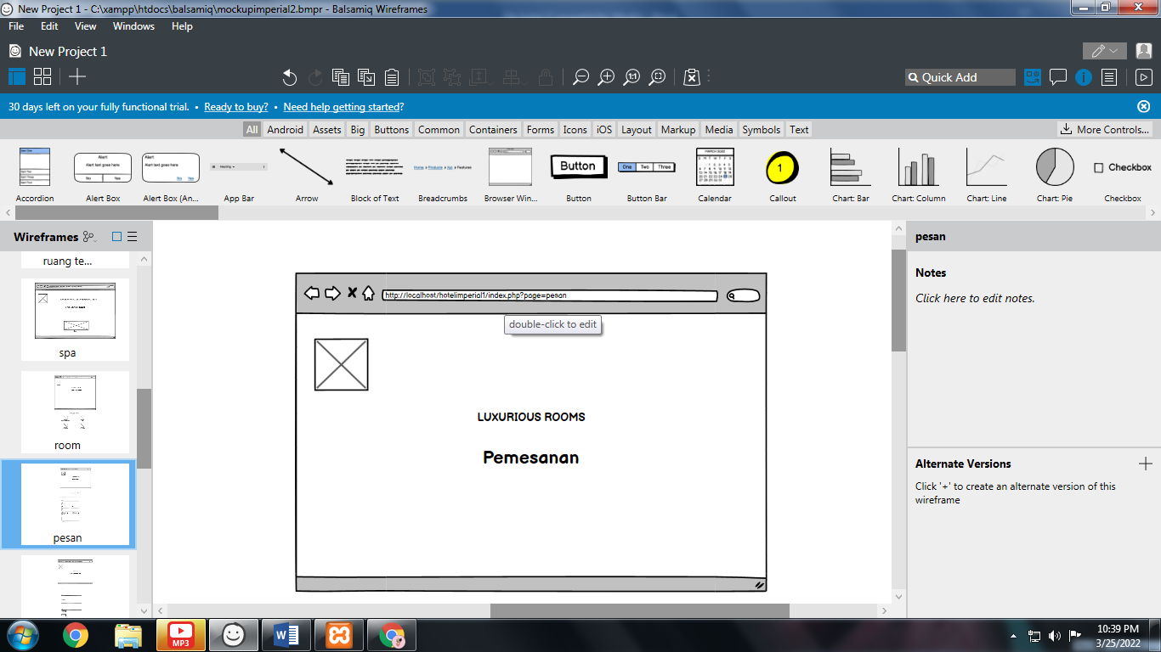

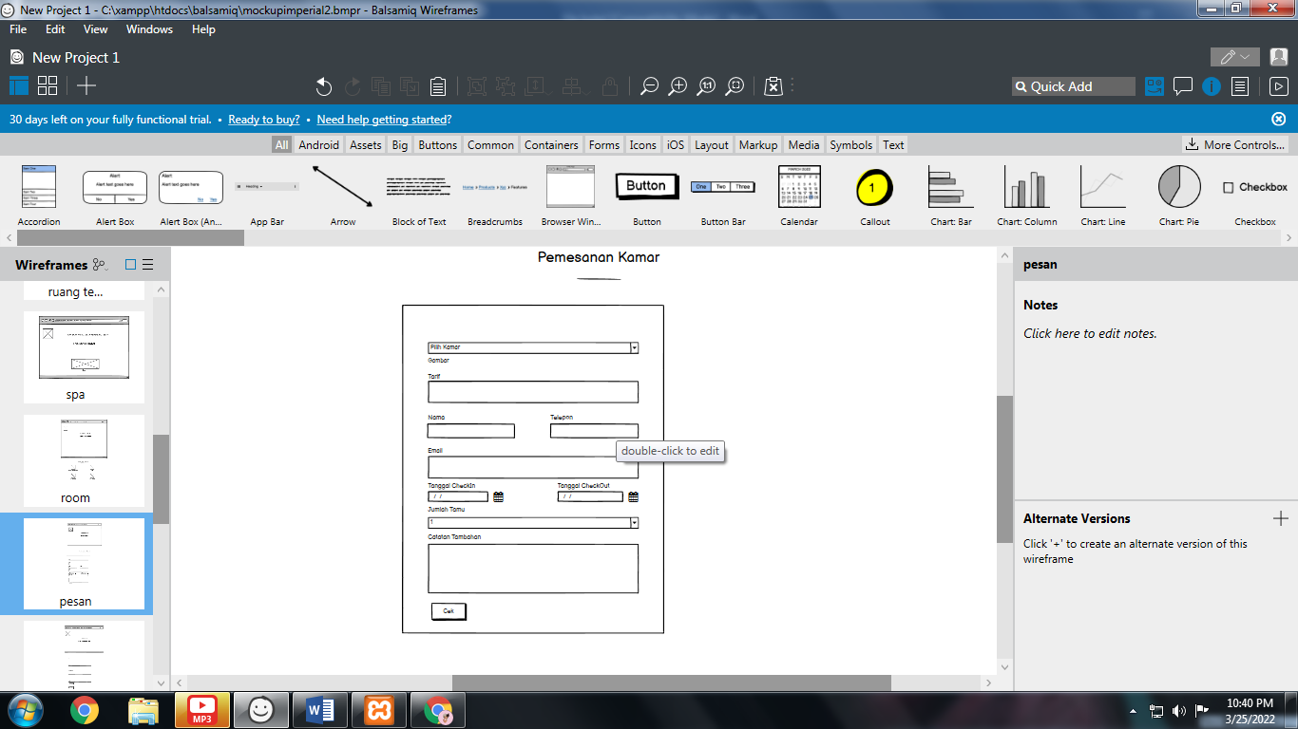

Konfirmasi pembayaran

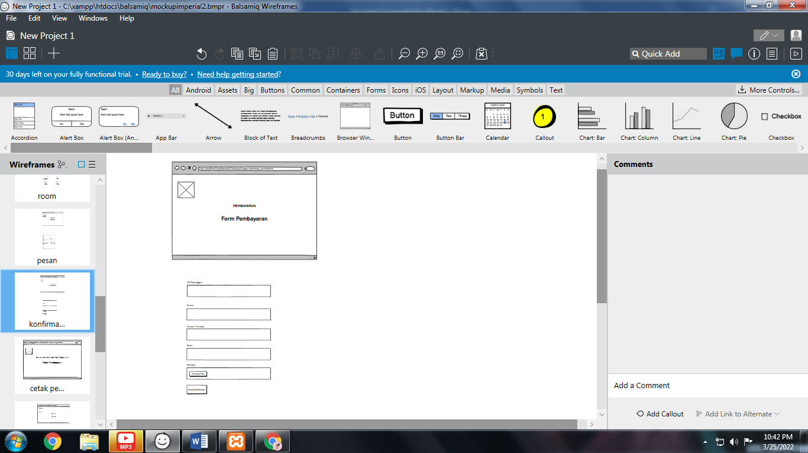

Cetak pembayaran

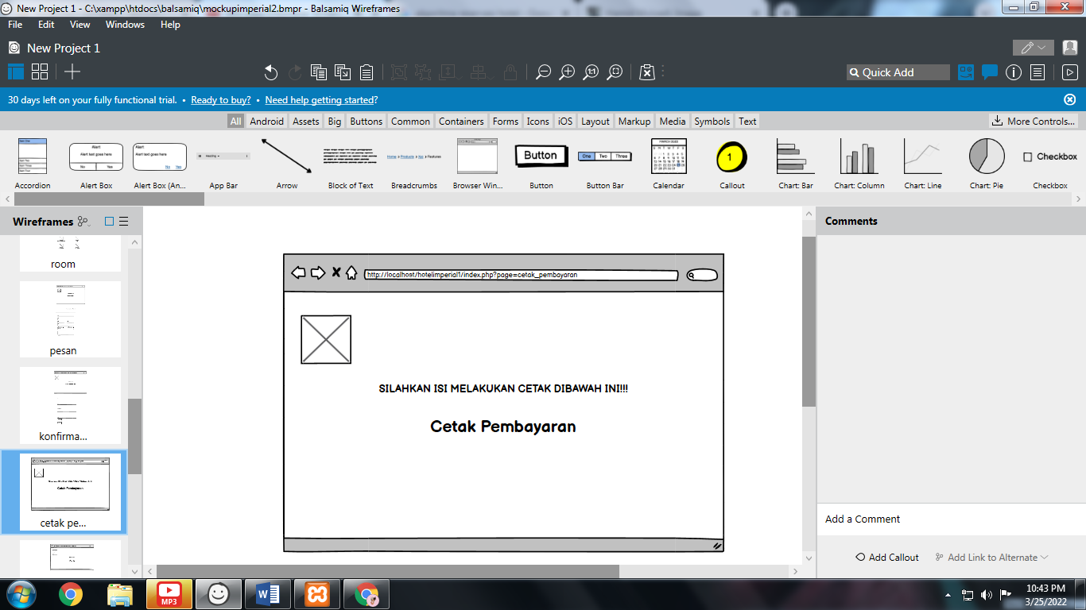

Event

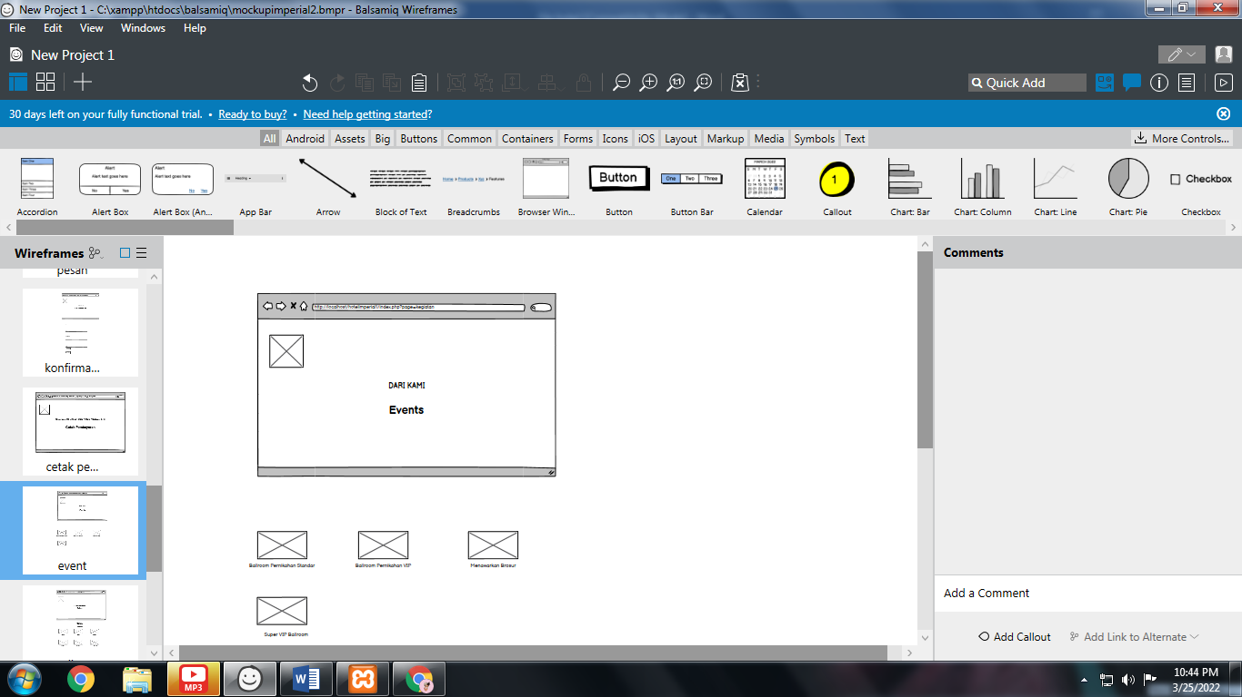

Galery

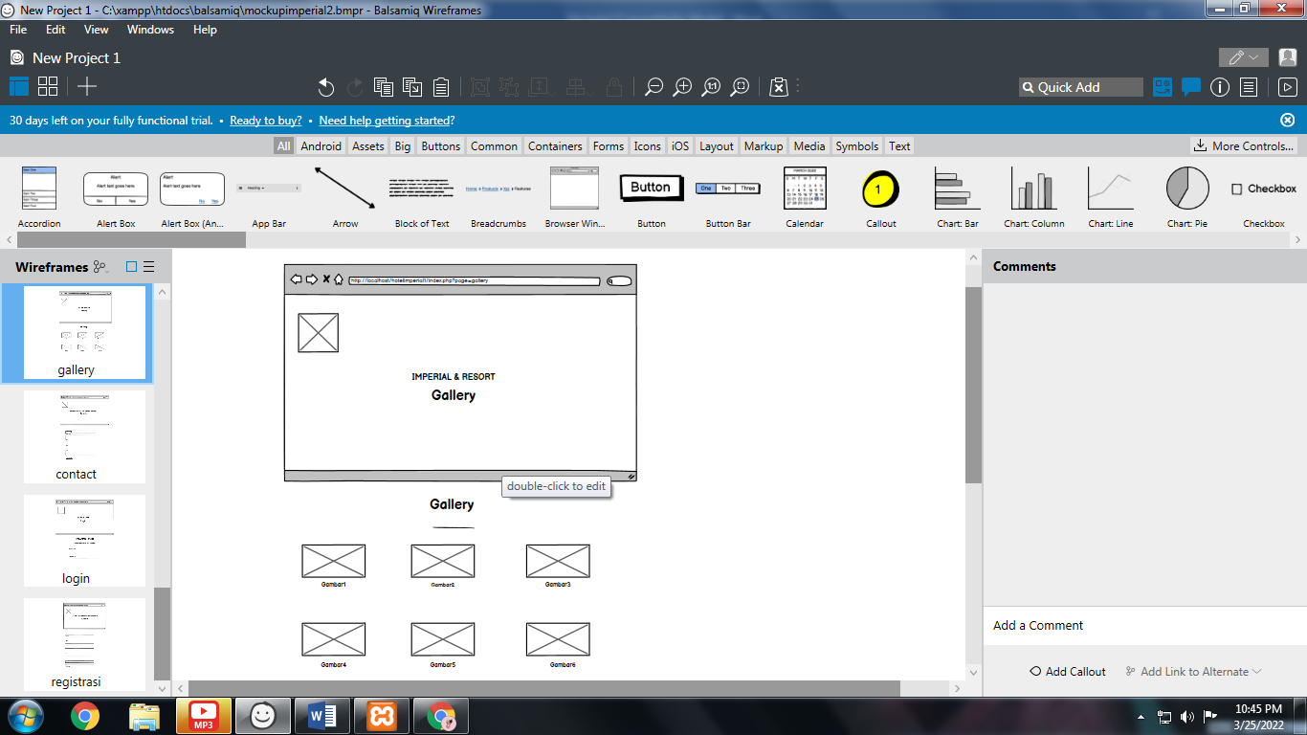

Contact

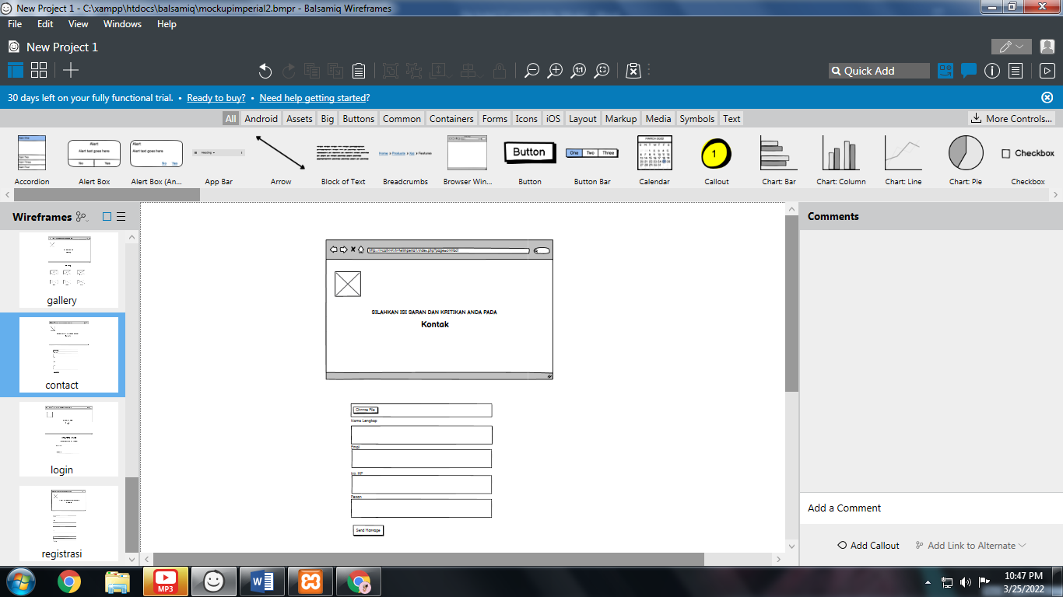

Login

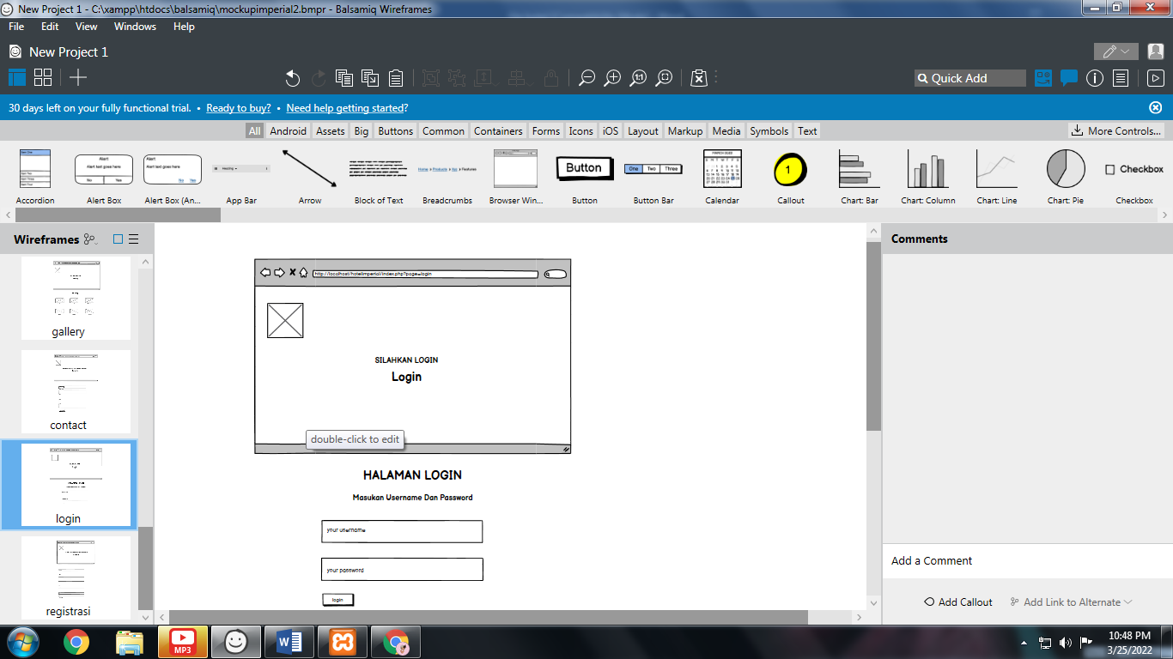

Regestrasi

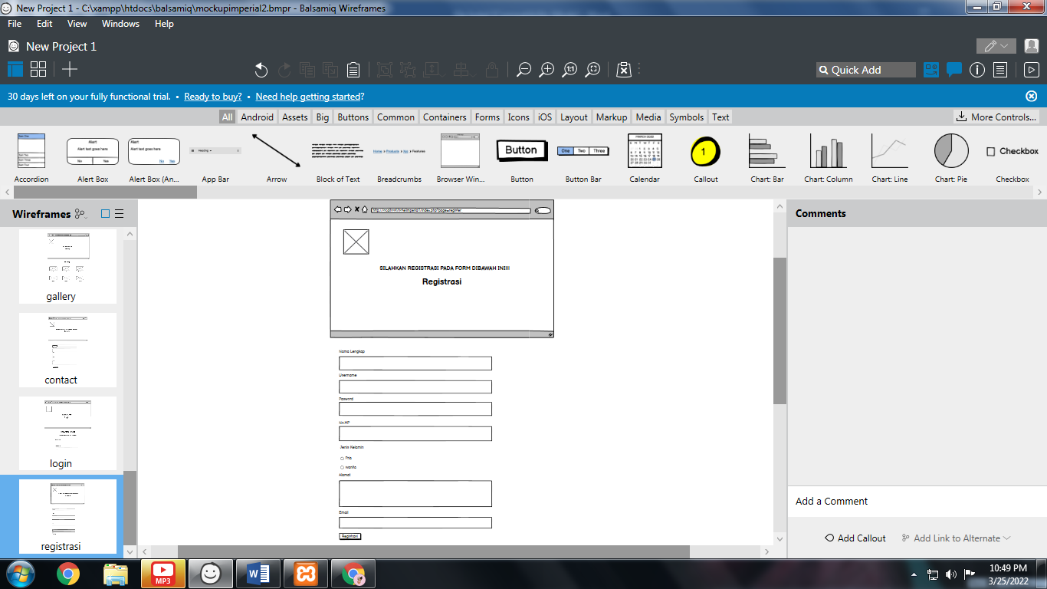

Halaman admin

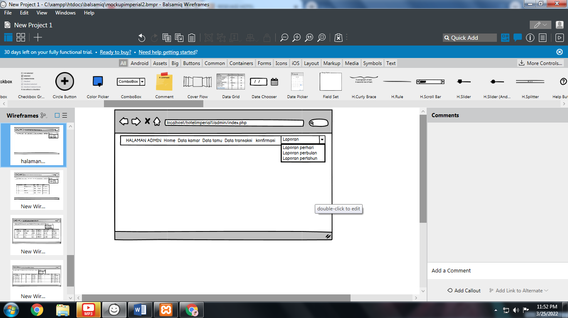

Data kamar

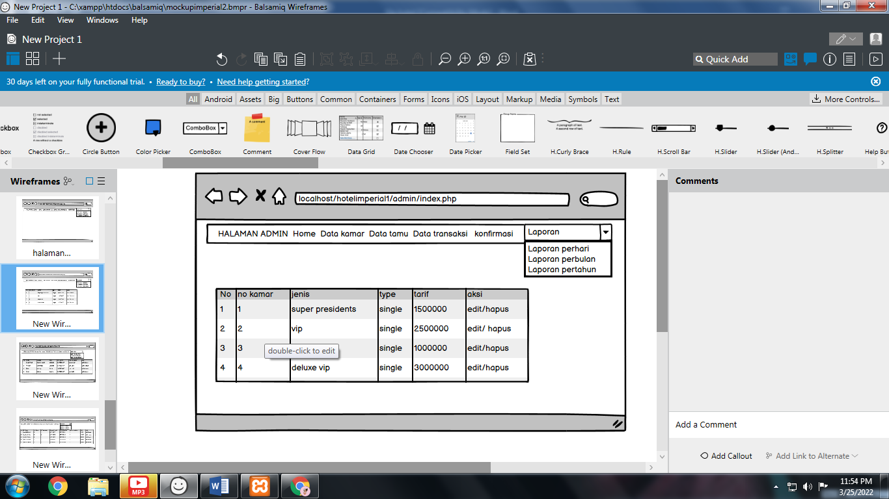

Data tamu

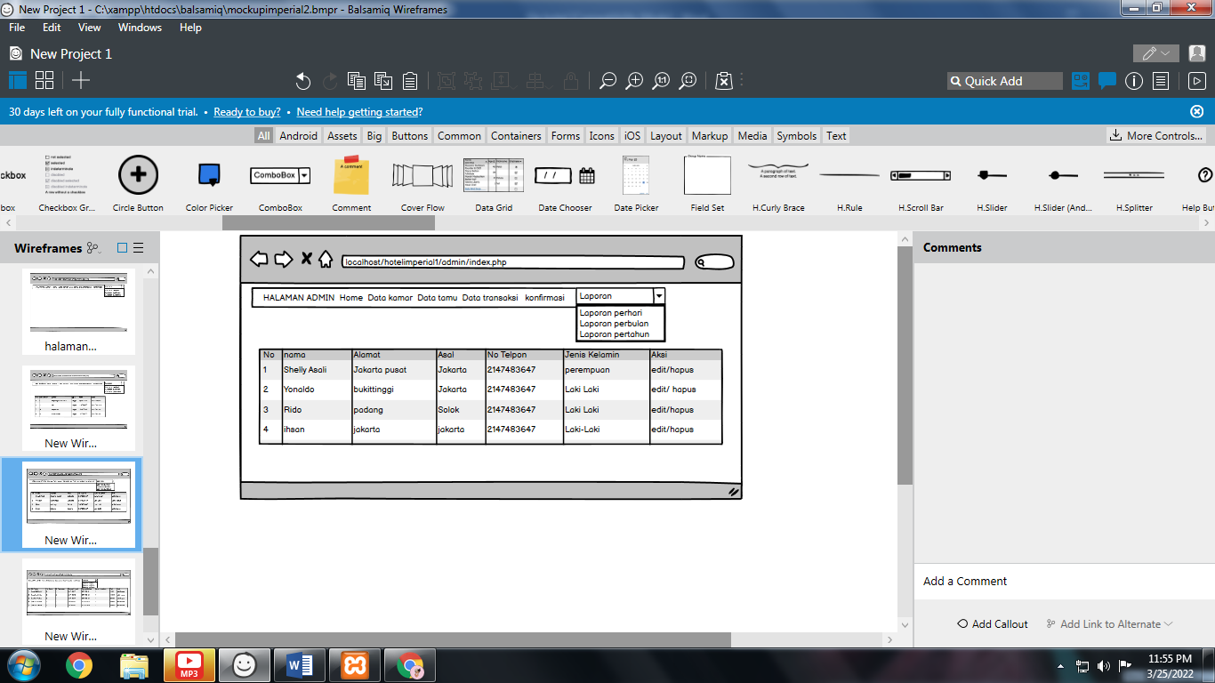

Data transaksi

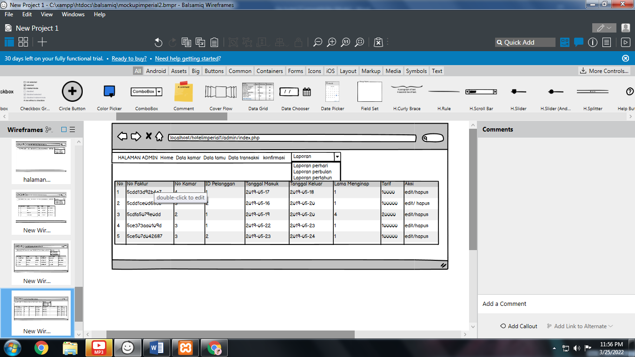

Konfirmasi

